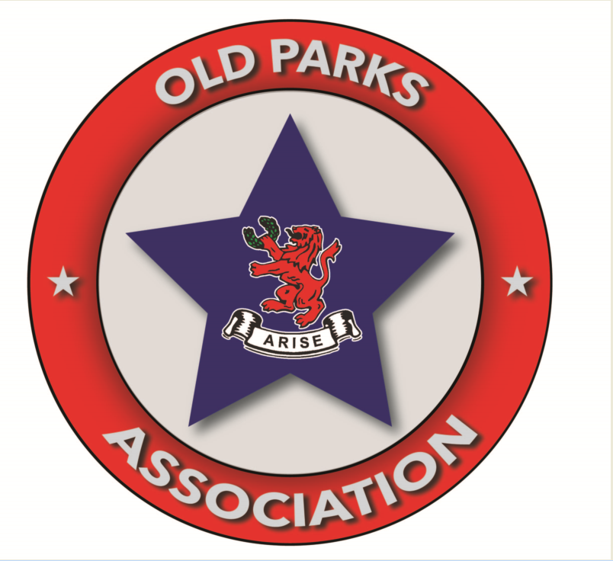

OLD PARKTONIAN ASSOCIATION
An association of Old Girls of Parktown Girls High School and Old Boys of Parktown Boys High School, contributing towards the continued prosperity of our beloved schools and their heritage, including the Old Parktonian Sports Club.

Application Form and Code of Conduct
Details of Applicant
First name and Surname:
ID Number:
E-mail address:
Mobile phone number:
Postal address:

I am an Old Girl/Old Boy (Year ________) / Parent of a Parktown Old Girl/Boy/ Teacher at Parktown Girls/Boys – circle one.
I hereby make application for membership of the Association and undertake to uphold the terms and conditions of membership (below), and to abide by the Constitutions of the Association and Sports Club (available on request).

Terms and Conditions of Membership
Subscriptions
- Acceptance of your application shall be communicated by way of an invoice on behalf of the Association in respect of the undermentioned annual subscription fee payable to the Association, and shall be renewed annually absent written notification of resignation from you/revocation to you, save that:
  - Membership for all Old Girls/Boys is free for the first year after school (first year Old Girls/Boys).
  - Membership for teachers is free.
- The annual subscription fee (decided at a Council Meeting by the Council), currently R380.00, is due in full by 1 October of each year. Failure to pay will result in your membership being revoked.
- Payment is to be made to Old Parktonian Sports Club, Standard Bank cheque account number 022286349, branch 006605 with reference: OPA, your initial and surname. Confirmation of payment must be sent to info@oldparks.co.za, after which your payment will be passed on to the Association.
Behaviour and dress
- No drunken and disorderly behaviour will be tolerated – this includes any form of aggressive behaviour.
- Language must be kept at a level befitting a Parktonian.
- Memorabilia, furniture, fixtures and fittings must be respected and looked after at all times. Damage to the above-mentioned property will be for the account of those parties responsible.
Disciplinary Action
- The Committee reserves the right to revoke membership should members fail to pay their subscriptions or be found guilty of contravening any other terms and conditions of membership or provision in the Constitutions of the Association and the Sports Club. Members may be requested to appear at a disciplinary hearing should the Committee find just cause. The Committee’s disciplinary decision is final.
Sports Club
- Association membership entitles you to access to and use of the facilities of the Old Parktonian Sports Club, provided that the trading hours, rules and governing documents of the Sports Club are adhered to at all times. Should you wish to participate in any sporting codes of the Sports Club, you are most welcome to become a member of the Sports Club, in which case you will be required to pay Sports Club membership fees (inquiries at info@oldparks.co.za or consult the Sports Club’s webpage info@oldparks.co.za).

Applicant Date Proposed by Date

Witness Date Chairman Date

